Case Study No.: 7
Title: To demonstrate the events handling in javascript
a)Access and manipulate form elements using js.
b) Validate user inputs(e.g. Email, empty fields).
c) Use various form events (submit,change,focus)
Create the following html form and use required js and events in a given form (first name, last name, email, birthday, password, reenter password, agree to the terms and conditions)
Software/Tools Required: HTML5, CSS3, JavaScript, VS Code, Google Chrome
Index.html:
<!DOCTYPE html>
<html lang="en">
<head>
<meta charset="UTF-8">
<meta name="viewport" content="width=device-width, initial-scale=1.0">
<title>Registration Form</title>
<link rel="stylesheet" href="style.css">
</head>
<body>
<div class="form-container">
<h2>Registration Form</h2>
<form id="registrationForm">
<div class="form-group">
<label for="firstName">First Name</label>
<input type="text" id="firstName" placeholder="Enter first name">
<span class="error" id="firstNameError"></span>
</div>
<div class="form-group">
<label for="lastName">Last Name</label>
<input type="text" id="lastName" placeholder="Enter last name">
<span class="error" id="lastNameError"></span>
</div>
<div class="form-group">
<label for="email">Email</label>
<input type="text" id="email" placeholder="example@gmail.com">
<span class="error" id="emailError"></span>
</div>
<div class="form-group">
<label for="birthday">Birthday</label>
<input type="date" id="birthday">
<span class="error" id="birthdayError"></span>
</div>
<div class="form-group">
<label for="password">Password</label>
<input type="password" id="password" placeholder="Enter password">
<span class="error" id="passwordError"></span>
</div>
<div class="form-group">
<label for="rePassword">Re-enter Password</label>
<input type="password" id="rePassword" placeholder="Re-enter password">
<span class="error" id="rePasswordError"></span>
</div>
<div class="terms">
<input type="checkbox" id="terms">
<label for="terms">
I agree to the Terms and Conditions
</label>
</div>
<span class="error" id="termsError"></span>
<button type="submit">Register</button>
<p id="successMessage"></p>
</form>
</div>
<script src="script.js"></script>
</body>
</html>
Script.js:
const form = document.getElementById("registrationForm");
const firstName = document.getElementById("firstName");
const lastName = document.getElementById("lastName");
const email = document.getElementById("email");
const birthday = document.getElementById("birthday");
const password = document.getElementById("password");
const rePassword = document.getElementById("rePassword");
const terms = document.getElementById("terms");
const firstNameError = document.getElementById("firstNameError");
const lastNameError = document.getElementById("lastNameError");
const emailError = document.getElementById("emailError");
const birthdayError = document.getElementById("birthdayError");
const passwordError = document.getElementById("passwordError");
const rePasswordError = document.getElementById("rePasswordError");
const termsError = document.getElementById("termsError");
const successMessage = document.getElementById("successMessage");
firstName.addEventListener("focus", function () {
firstName.style.backgroundColor = "#eef7ff";
});
lastName.addEventListener("focus", function () {
lastName.style.backgroundColor = "#eef7ff";
});
email.addEventListener("focus", function () {
email.style.backgroundColor = "#eef7ff";
});
password.addEventListener("focus", function () {
password.style.backgroundColor = "#eef7ff";
});
rePassword.addEventListener("focus", function () {
rePassword.style.backgroundColor = "#eef7ff";
});
email.addEventListener("change", function () {
const emailValue = email.value.trim();
const emailPattern = /^[^\s@]+@[^\s@]+\.[^\s@]+$/;
if (emailValue === "") {
emailError.textContent = "Email is required.";
emailError.style.color = "red";
}
else if (!emailPattern.test(emailValue)) {
emailError.textContent = "Please enter a valid email address.";
emailError.style.color = "red";
}
else {
emailError.textContent = "Valid email address.";
emailError.style.color = "green";
}
});
password.addEventListener("change", function () {
if (password.value.length < 6) {
passwordError.textContent =
"Password must contain at least 6 characters.";
}
else {
passwordError.textContent = "";
}
});
rePassword.addEventListener("change", function () {
if (rePassword.value !== password.value) {
rePasswordError.textContent =
"Passwords do not match.";
}
else {
rePasswordError.textContent = "";
}
});
form.addEventListener("submit", function (event) {
event.preventDefault();
firstNameError.textContent = "";
lastNameError.textContent = "";
emailError.textContent = "";
birthdayError.textContent = "";
passwordError.textContent = "";
rePasswordError.textContent = "";
termsError.textContent = "";
successMessage.textContent = "";
let isValid = true;
if (firstName.value.trim() === "") {
firstNameError.textContent =
"First name is required.";
isValid = false;
}
if (lastName.value.trim() === "") {
lastNameError.textContent =
"Last name is required.";
isValid = false;
}
const emailValue = email.value.trim();
const emailPattern = /^[^\s@]+@[^\s@]+\.[^\s@]+$/;
if (emailValue === "") {
emailError.textContent =
"Email is required.";
isValid = false;
}
else if (!emailPattern.test(emailValue)) {
emailError.textContent =
"Please enter a valid email address.";
isValid = false;
}
if (birthday.value === "") {
birthdayError.textContent =
"Birthday is required.";
isValid = false;
}
if (password.value === "") {
passwordError.textContent =
"Password is required.";
isValid = false;
}
else if (password.value.length < 6) {
passwordError.textContent =
"Password must contain at least 6 characters.";
isValid = false;
}
if (rePassword.value === "") {
rePasswordError.textContent =
"Please re-enter your password.";
isValid = false;
}
else if (password.value !== rePassword.value) {
rePasswordError.textContent =
"Passwords do not match.";
isValid = false;
}
if (!terms.checked) {
termsError.textContent =
"You must agree to the Terms and Conditions.";
isValid = false;
}
if (isValid) {
successMessage.textContent =
"Registration successful!";
form.reset();
}
});
Style.css:
* {
box-sizing: border-box;
font-family: Arial, sans-serif;
}
body {
margin: 0;
background-color: #f9d5d5;
display: flex;
justify-content: center;
align-items: center;
min-height: 100vh;
}
.form-container {
width: 900px;
background-color: white;
padding: 30px;
border-radius: 10px;
box-shadow: 0 0 15px rgba(0, 0, 0, 0.15);
}
h2 {
text-align: center;
margin-bottom: 25px;
}
.form-group {
margin-bottom: 18px;
}
label {
display: block;
margin-bottom: 6px;
font-weight: bold;
}
input[type="text"],
input[type="password"],
input[type="date"] {
width: 100%;
padding: 10px;
border: 1px solid #aaa;
border-radius: 5px;
font-size: 14px;
}
input:focus {
outline: none;
border: 2px solid #007bff;
background-color: #f5faff;
}
.error {
display: block;
color: red;
font-size: 13px;
margin-top: 5px;
}
.terms {
display: flex;
align-items: center;
gap: 8px;
margin-bottom: 5px;
}
.terms input {
width: auto;
}
.terms label {
margin: 0;
font-weight: normal;
}
button {
width: 100%;
padding: 11px;
margin-top: 20px;
background-color: #007bff;
color: white;
border: none;
border-radius: 5px;
font-size: 16px;
cursor: pointer;
}
button:hover {
background-color: #0056b3;
}
#successMessage {
text-align: center;
color: green;
font-weight: bold;
margin-top: 15px;
}

Output:

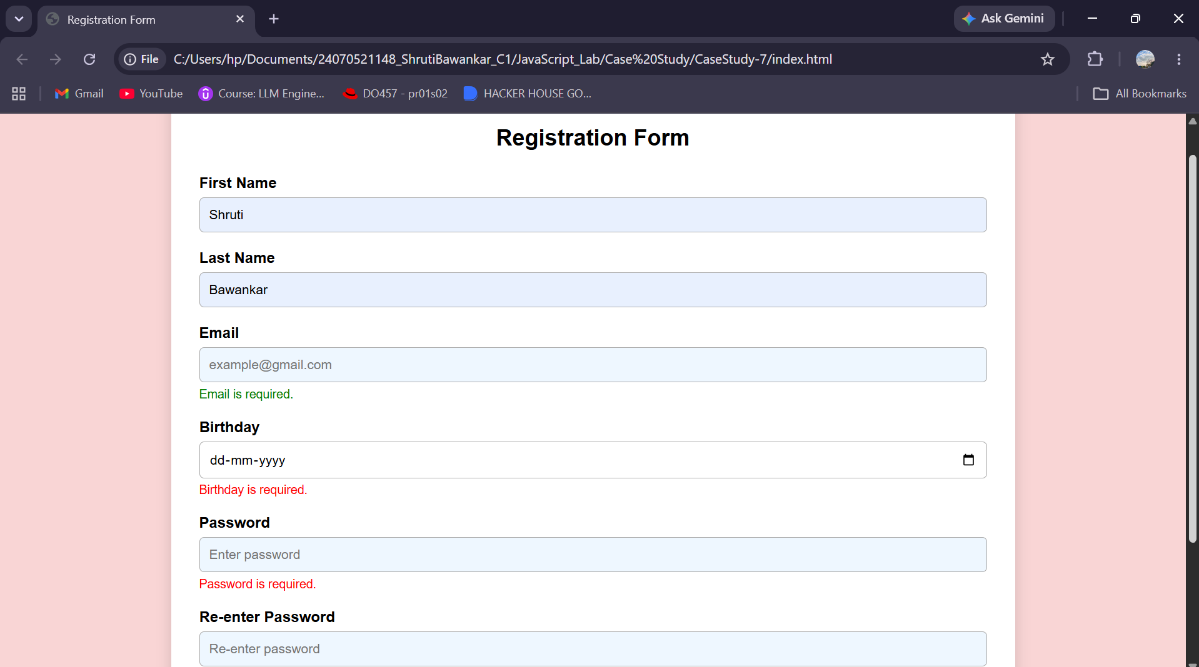
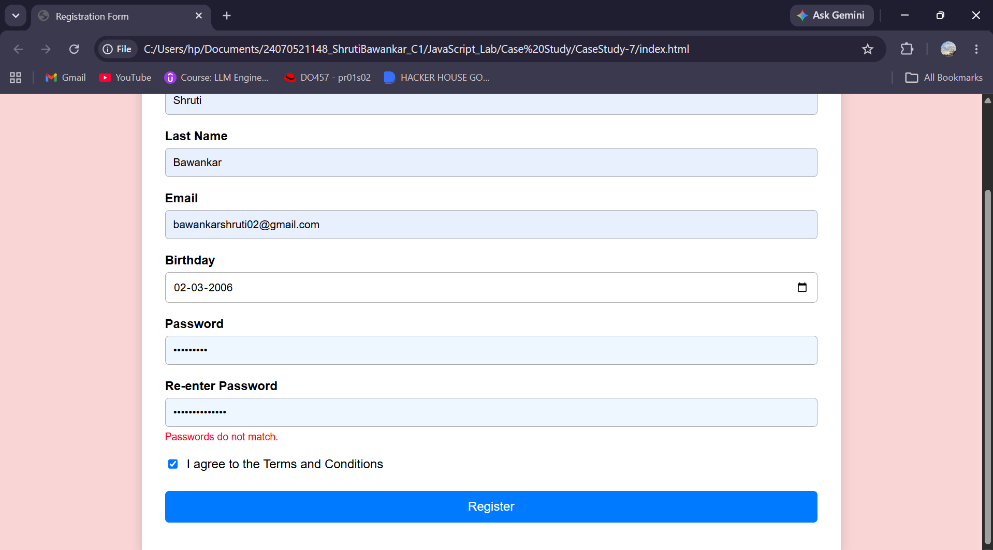
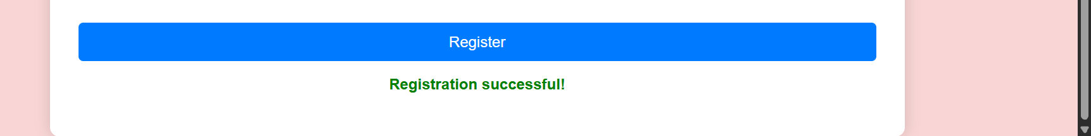

Result: The registration form was successfully created with JavaScript event handling and input validation for email, password, required fields, and terms acceptance.
Conclusion: Thus, focus, change, and submit events were successfully implemented to provide interactive and reliable form validation.

